MICROCONTROLLER BASED SMS CONTROLLING MOVING ROBOT

The advent of new high-speed technology and the growing computer capacity provided realistic opportunity for new robot controls and realization of new methods of control theory. This technical improvement together with the need for high performance robots created faster, more accurate and more intelligent robots using new robots control devices, new drives and advanced control algorithms.

This project describes a new economical solution of robot control systems. The presented robot control system can be used for different sophisticated robot applications. The control system consists of a GSM modem, a microcontroller that collects data from the modem and controls the robot.

Robot is a system that contains sensors, control systems, manipulators, power supplies and software all working together to perform a task. Designing, building, programming and testing a robot is a combination of physics, mechanical engineering, electrical engineering, structural engineering, mathematics and computing. In some cases biology, medicine, chemistry might also be involved.

A complete solution of a robot control solution is presented in this project. The robot is fully controlled by the microcontroller and the information received by the modem is received by the microcontroller. The mechanical arrangement to the robot is arranged to the robot as a robotic car.

Thus, in order to control the robotic car using GSM, the user has to send the predefined messages to the modem. When the modem receives these predefined messages, it intimates the same to the microcontroller. The microcontroller upon receiving the information from the modem acts in accordance to the message, making it a highly automated application.

BLOCK DIAGRAM

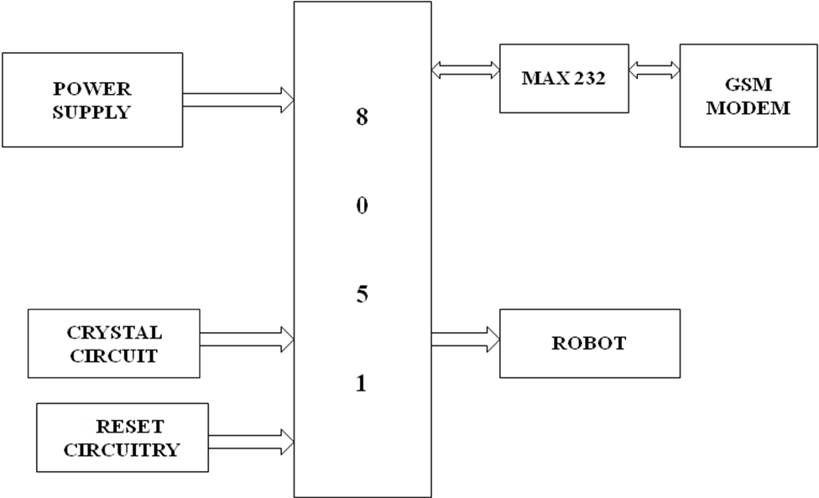

SOFTWARE AND HARDWARE TOOLS:
Software Tools:
- Keil compiler
- Orcad.
- Proload

Hardware Tools:
- Microcontroller AT89S52.
- Motors and driver circuit
- MAX232
- GSM MODEM

